Assignment 6 - Game of Thrones Report

Isidro Moroso Varona

2025-05-05

# Load season data from CSV passed via parameter  
season_data <- read.csv(params$season_file)

# Game of Thrones - Season 1 summary in numbers

### **(*Warning:* spoilers ahead)**

### Overview

(From the [Wikipedia](https://en.wikipedia.org/wiki/Game_of_Thrones#Premise)) Game of Thrones is an American fantasy drama television series created by David Benioff and D. B. Weiss for HBO. It is an adaptation of *A Song of Ice and Fire*, a series of fantasy novels by George R. R. Martin, the first of which is *A Game of Thrones*.

Set on the fictional continents of Westeros and Essos, Game of Thrones has a large ensemble cast and follows several story arcs throughout the course of the show. A major arc concerns the Iron Throne of the Seven Kingdoms of Westeros through a web of political conflicts among the noble families either vying to claim the throne or fighting for independence from it. Another focuses on the last descendant of the realm’s deposed ruling dynasty, who has been exiled to Essos and is plotting a return to the throne. A third story arc follows the Night’s Watch, a military order defending the realm against threats from the North.

### Season 1 summary

# Ensure viewers column exists  
if (!"viewers" %in% names(season_data)) stop("Missing 'viewers' column in dataset")  
  
viewers_avg <- mean(season_data$viewers, na.rm = TRUE)  
most_popular <- season_data[which.max(season_data$viewers), ]

Season 1 of *Game of Thrones* consisted of 10 episodes. The show gathered an average of 2.52 million first-day TV viewers in the US.

The most popular episode of the season was **““**, directed by , which had 3.04 million viewers.

You can see how the viewership of the episodes changed in Figure 1.

plot(season_data$viewers, type = "l", col = "darkred", lwd = 3,  
 xlab = "Episode number", ylab = "Viewers (millions)",  
 main = paste("Season", params$season_number, "Viewership"))

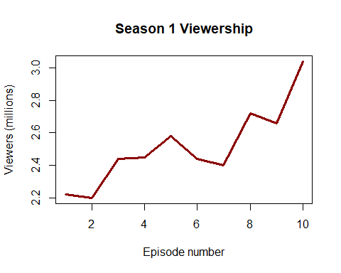

Finally, the episodes with the above-average viewership were:

above_avg <- season_data[season_data$viewers > viewers_avg, ]

# Use correct column names based on CSV

knitr::kable(above_avg[, c(“Episode”, “Title”, “Director”)], col.names = c(“Episode”, “Title”, “Directed by”))